Name Brandon Kinard

Box # 364

Cairn University School of Business

CIS122 Essentials of Networking

Project # 2

Project objective: We are trying to get the raspberry pi to connect with one in the cabinet, trying to connect using ip address

Equipment used:

|  |  |  |  |  |
| --- | --- | --- | --- | --- |
| Equipment Description | Vendor | Vendor Item # | Retail price | Actual price (if known) |
| Fiber optic cable | Newegg | N82E16812120970 | $24.99 | $14.36 |
| ethernet cable | Newegg | 9SIAFVD74G9226 | $14.99 | $2.99 |
| switch | Newegg | 12K-008X-00023 | $179 | $179 |

Detailed list of software and operating platforms used, including version numbers and licensing requirements:

we did this using a windows 10 pc

Network diagram:

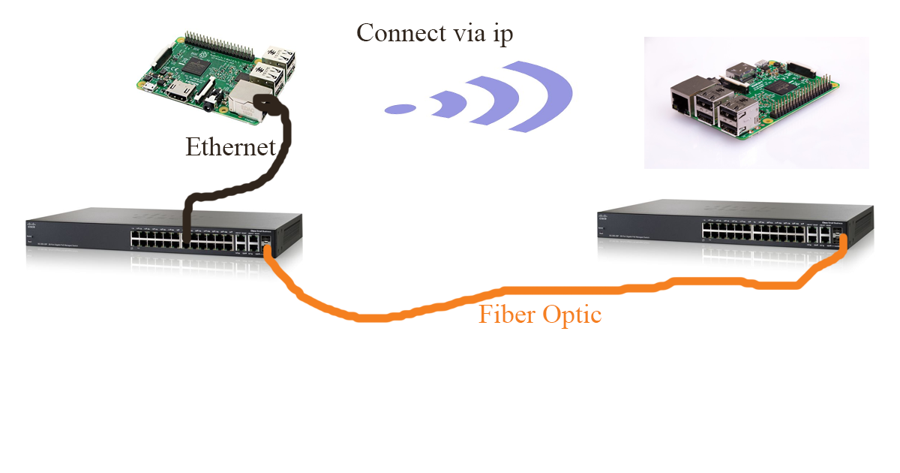

Configurations:

We connected the switch fsp port and then plugged it into the cabinet. Connected the raspberry pie to the switch, tested to see if it worked. it didn't. so we plugged the raspberry pi into the switch then retested it, it worked fine